Quadratic Optimization Problem
  - Exercise 1: IIA4117
The task was to solve the quadratic optimization problem given by the equations underneath.
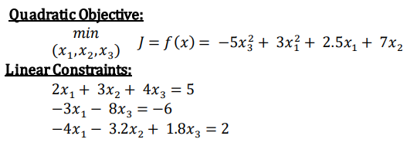
To do this, they must first be written on the standard form:
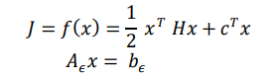
The resulting vectors and matrices can be seen here
$$H= \left[\begin{matrix}6 & 0 & 0 \\ 0 & 0 & 0 \\ 0 & 0 & -10\end{matrix}\right]$$
$$c= \left[\begin{matrix}2.5 \\ 7 \\ 0\end{matrix}\right]$$
$$x= \left[\begin{matrix}x_{1} \\ x_{2} \\ x_{3}\end{matrix}\right]$$
$$A_{ϵ}= \left[\begin{matrix}2 & 3 & 4 \\ -3 & 0 & -8 \\ -4 & -3.2 & 1.8\end{matrix}\right]$$
$$b= \left[\begin{matrix}5 \\ -6 \\ 2\end{matrix}\right]$$
We also needed the upper and lower bounds of the x vector.
$$x_{upper}= \left[\begin{matrix}∞ \\ ∞ \\ ∞\end{matrix}\right],x_{lower}= \left[\begin{matrix}-∞ \\ -∞ \\ -∞\end{matrix}\right]$$
The MATLAB function for setting this up in Simulink can be seen underneath.

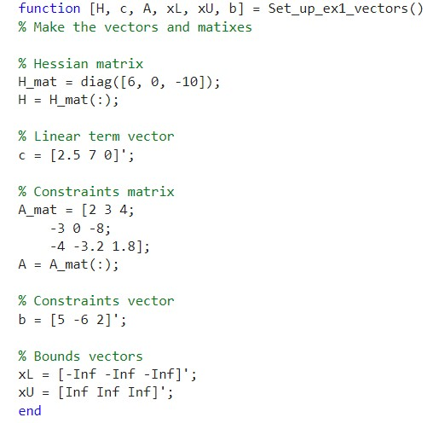
To solve the actual problem, the solver qpOASES was used with a sampling time of 0.1, 3 input controls, 5000 as max iterations and semidef Hessian type. The implementation before the compilation can be seen here: 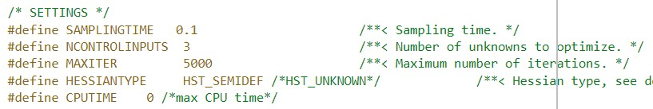
The outputs of the MATLAB function where connected to the inputs of the solver and the output of the solver to a scope for visualisation. The resulting simulation can be seen underneath.
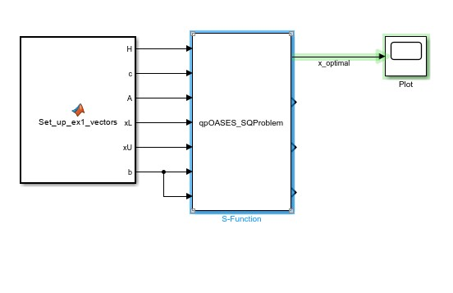
Then the simulation was run with a fixed step of 0.1, using the Runge Kutta 4 method, and a stop time of 0.1 since the solution is finale and will not evolve after the first step. Results for the x vector can be seen here:
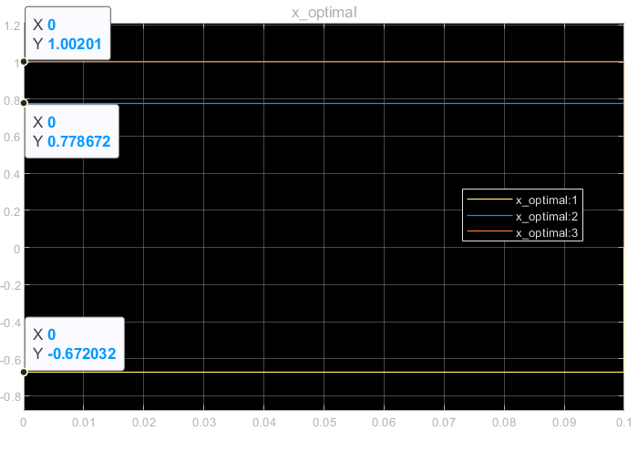
From this it is possible to see that the optimal values for x are
$$x_{optimal}= \left[\begin{matrix}-0.672032 \\ 0.778672 \\ 1.00201\end{matrix}\right]$$

